1.

Write the CSS file for the following HTML page ?

|  |
| --- |
| **CSS background-color example!**  This is a text inside a div element.  This paragraph has its own background color.  We are still in the div element. |

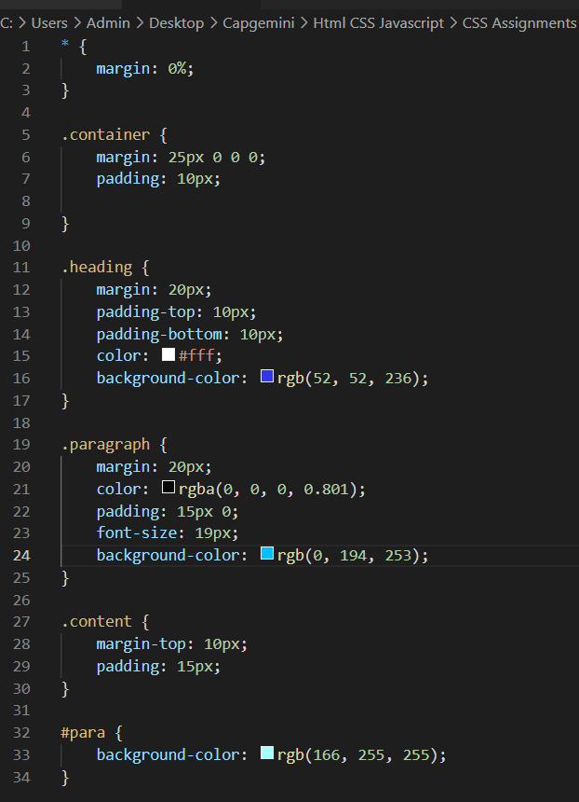

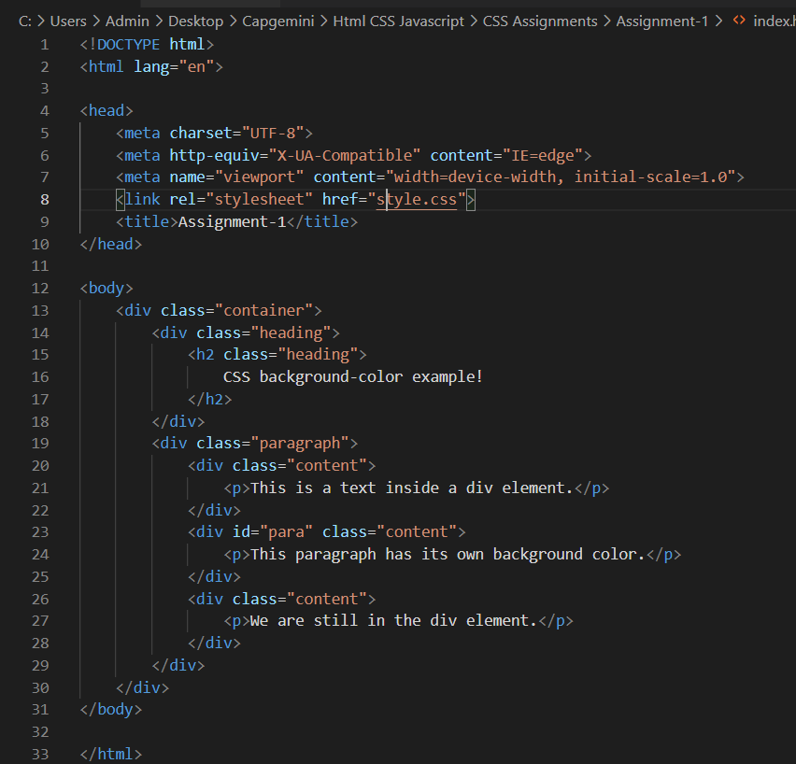

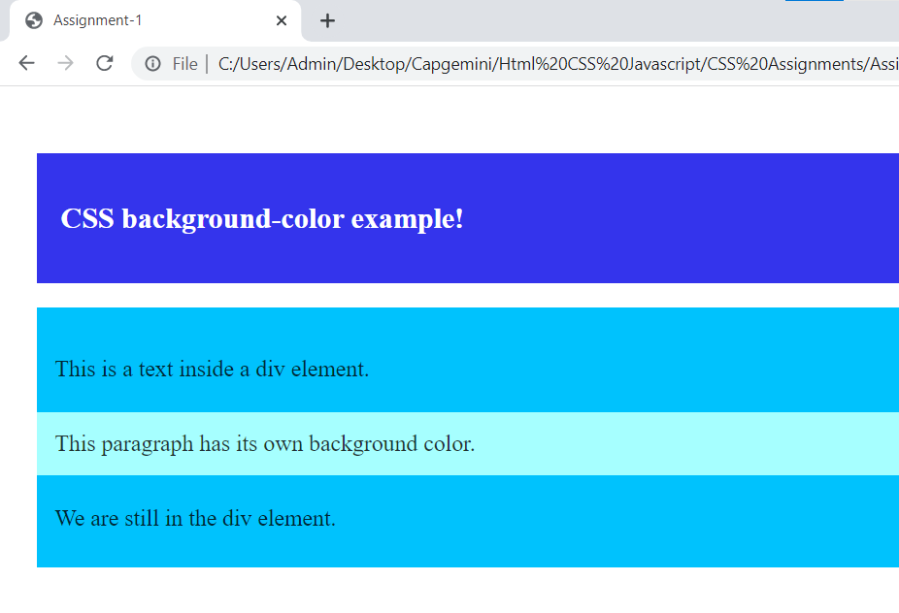

2.

Write the CSS file for the following HTML page?

|  |
| --- |
| **This is heading 1**  **~~This is heading 2~~**  **This is heading 3**  **This is heading 4** |

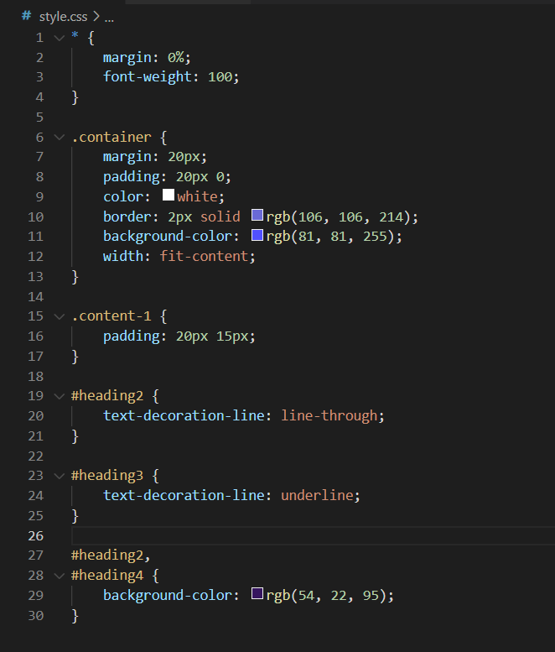

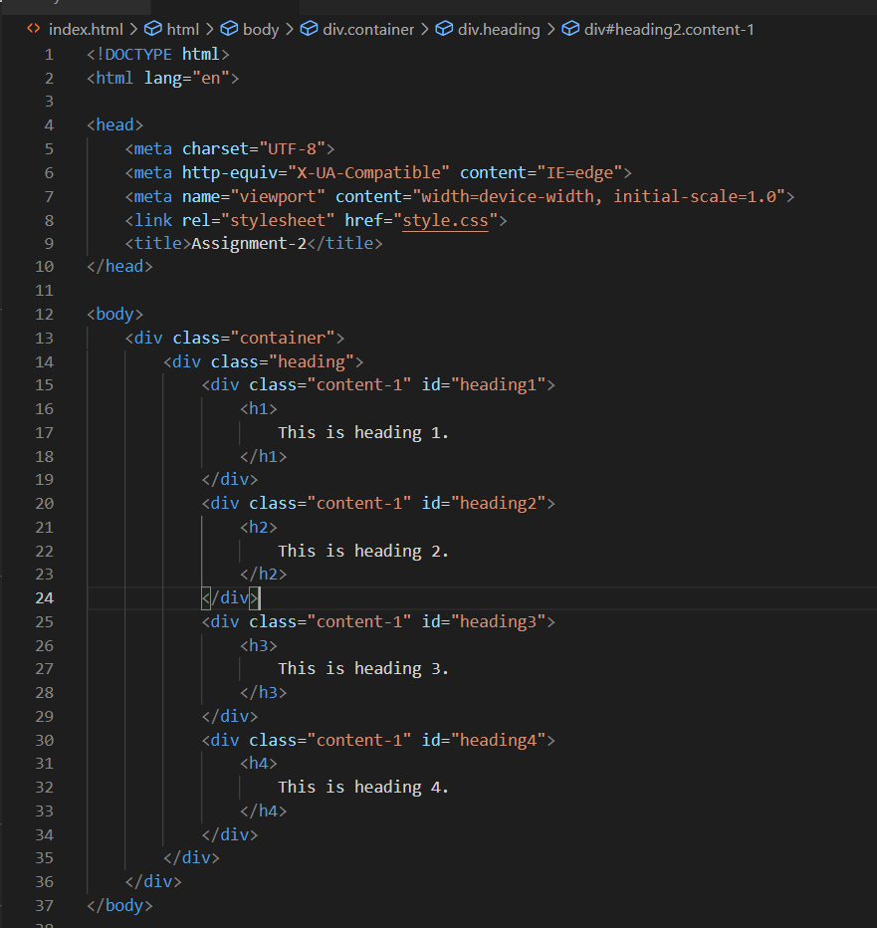

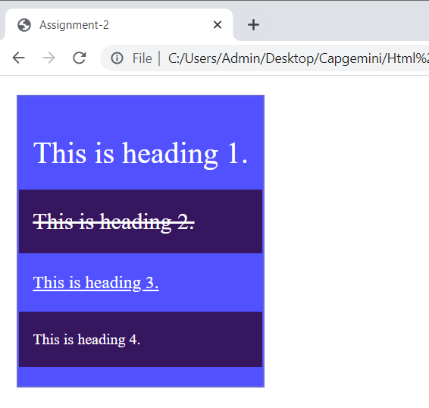

3. Write the CSS file for the following HTML page to display the text ?

|  |
| --- |
| This is some text.  This is some text.  This is some text. |

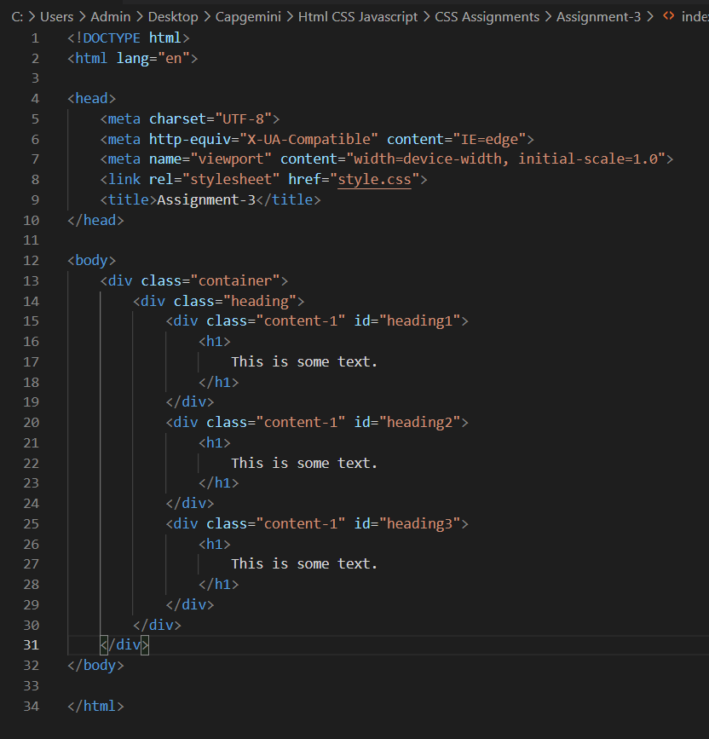

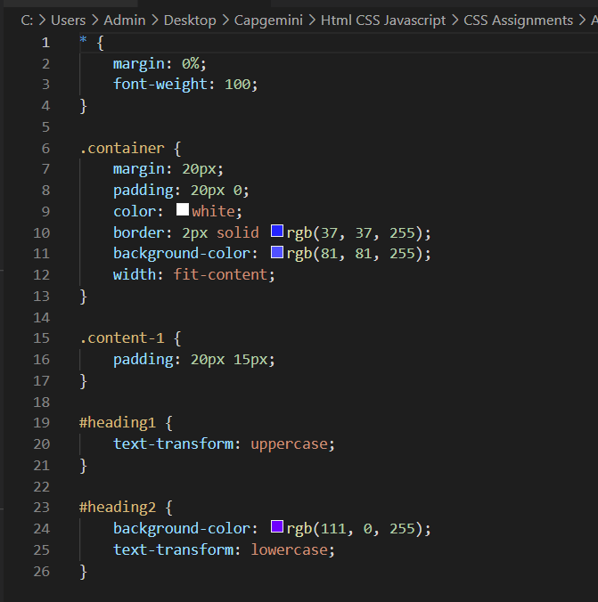

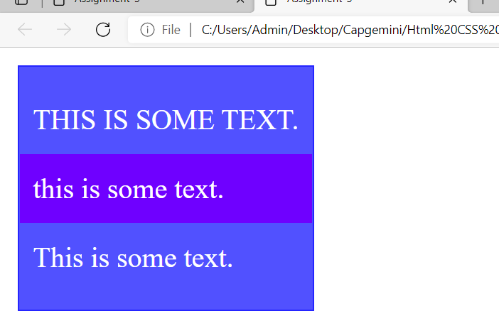

4. Write the CSS file for the following HTML page to Add different colors to visited/unvisited links

|  |
| --- |
| [**This is a link**](http://www.w3schools.com/css/default.asp) |
|  |

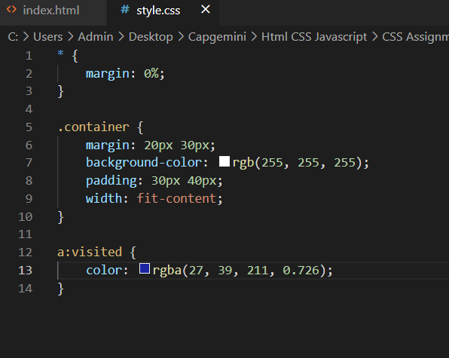

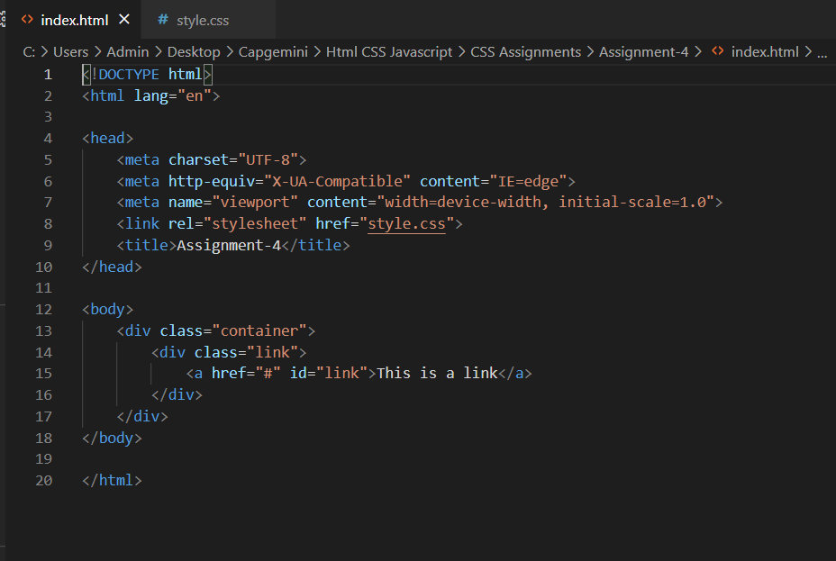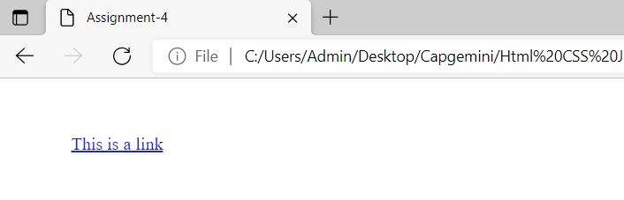

5.

Write the CSS file for the following HTML page?

|  |  |  |  |  |  |  |
| --- | --- | --- | --- | --- | --- | --- |
| |  |  | | --- | --- | | **Firstname** | **Lastname** | | Peter | Griffin | | Lois | Griffin | |

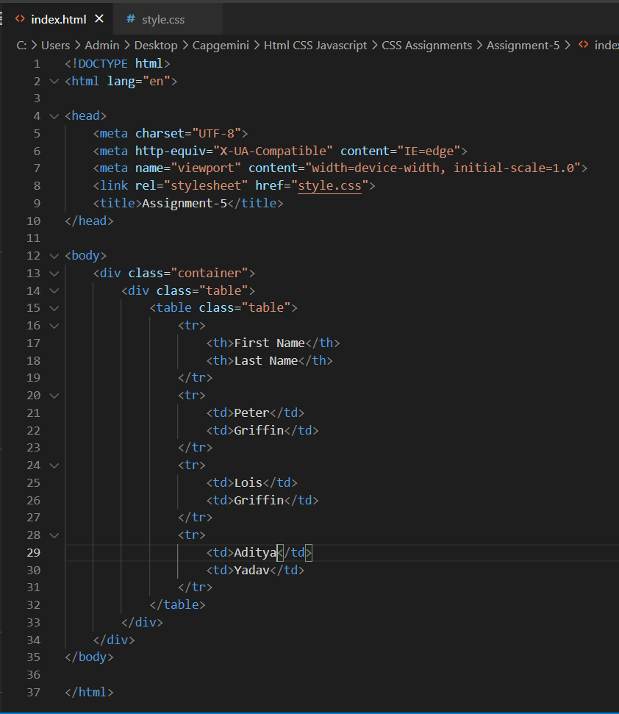

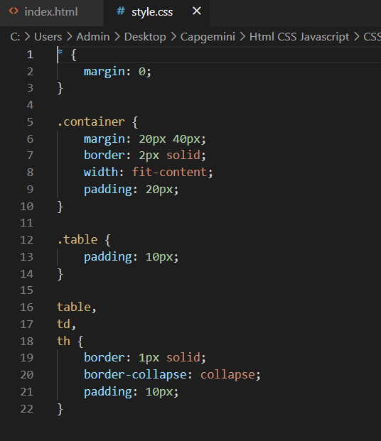

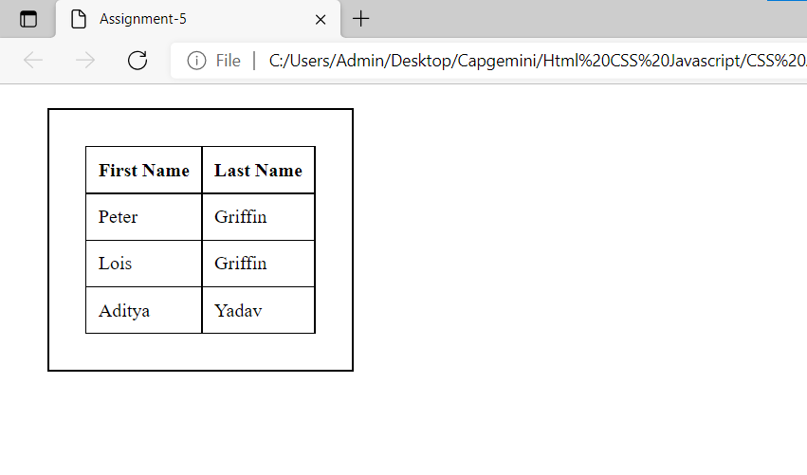

6. Write the CSS file for the following HTML page?

|  |  |  |  |  |  |  |  |  |  |  |  |  |  |  |  |
| --- | --- | --- | --- | --- | --- | --- | --- | --- | --- | --- | --- | --- | --- | --- | --- |
| |  |  |  | | --- | --- | --- | | **Firstname** | **Lastname** | **Savings** | | Peter | Griffin | $100 | | Lois | Griffin | $150 | | Joe | Swanson | $300 | | Cleveland | Brown | $250 | |

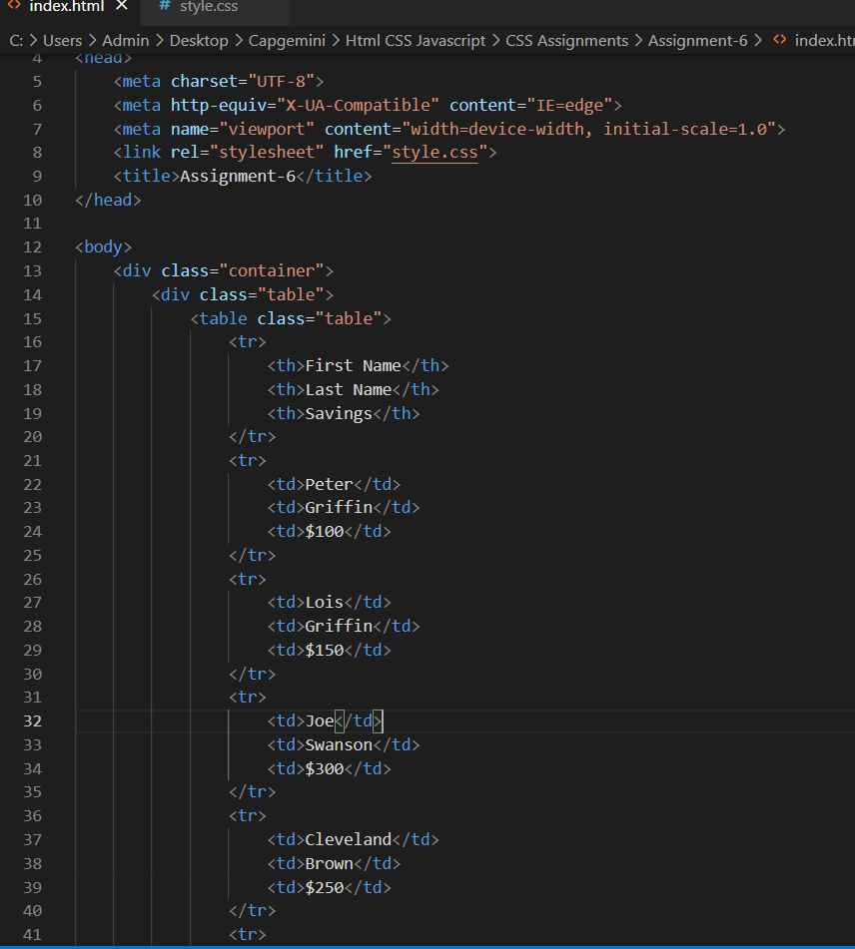

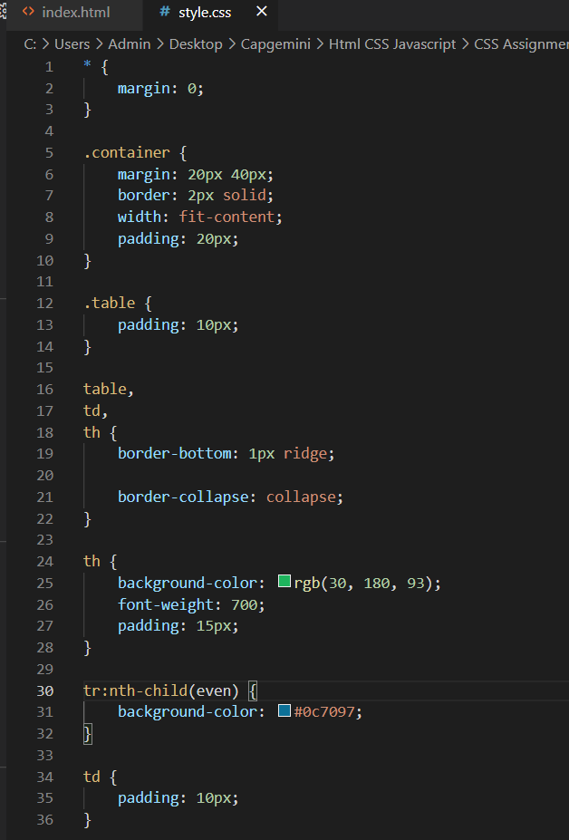

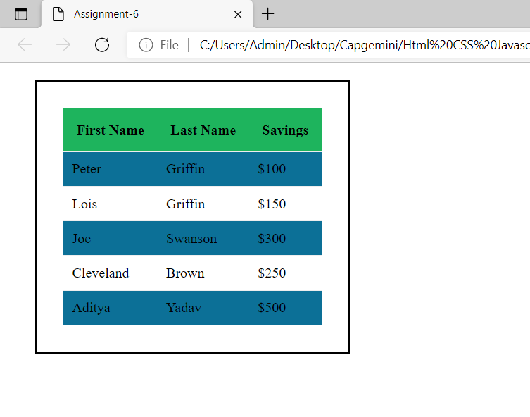

7. Write the CSS file for the following HTML page to set the color outline.

|  |
| --- |
|  |
|  |

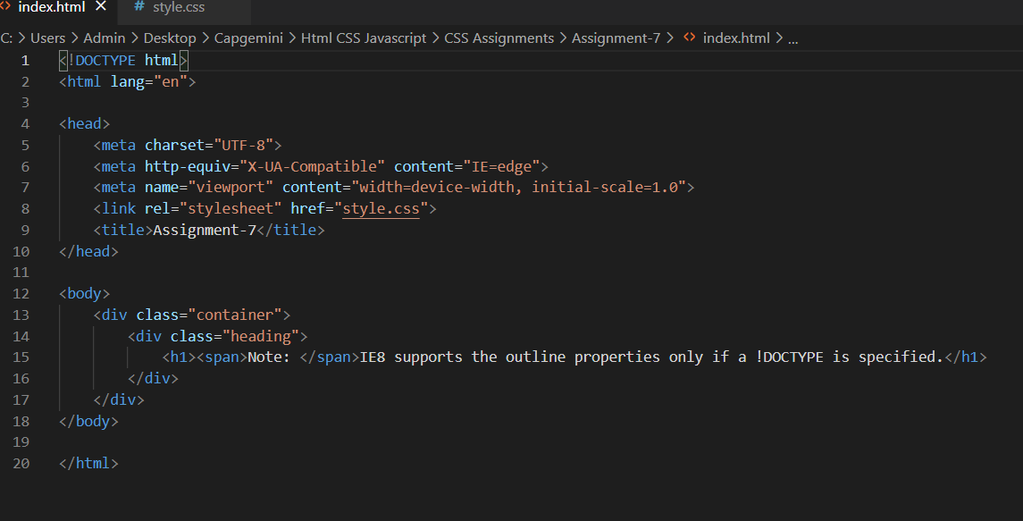

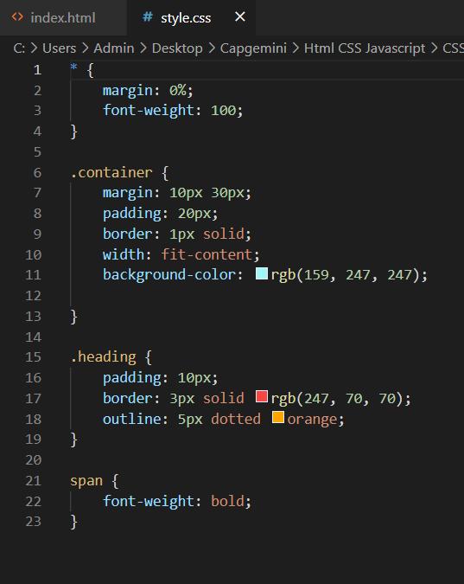

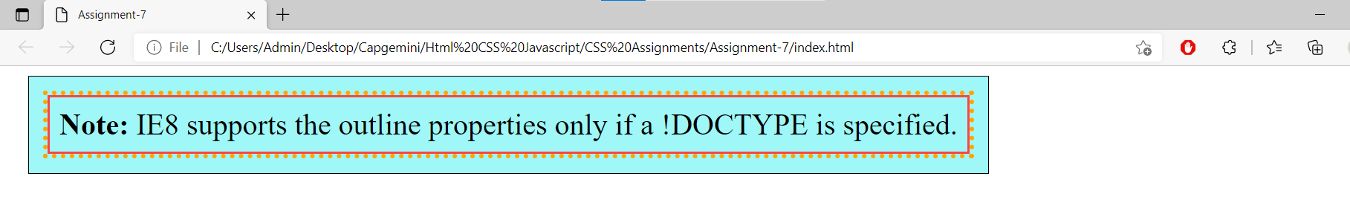

8. Write the CSS file for the following HTML page to set the border width of the page.

|  |
| --- |
| Some text.  Some text.  Some text. |

